Letter of Intent for participation in the Advisory Board of the Moonshot research trajectory Circularity of Carbon in Materials

Undersigned, [Company], with registered seat located at [Address], duly represented by [Name of Legal Representative], confirms it is strongly interested in the technology development within the Moonshot research trajectory Circularity of Carbon in Materials (MOT2).

Research trajectory ‘Circularity of Carbon in Materials’
The second Moonshot research trajectory (MOT2) aims at the development of a circular production and use chain of carbon and carbon-containing materials. The main objective of this research trajectory is to keep carbon in materials in circulation for as long as possible (throughout the value chain). The initial focus here is on plastics, which are omnipresent in our daily lives and which offer a wide range of properties and possibilities. For example, lightweight and innovative plastic materials in means of transport help to save energy, and packaging materials (usually made up of several layers of plastic) ensure that food can be stored in a reliable way, consequently reducing food waste. At the end of the life cycle of plastics, however, there are still major challenges, such as increasing the recycling percentage of plastics, which means that the added value per ton of carbon (as input) can be increased considerably. Extensive research into the mechanical and chemical recycling of complex plastics, which contain several types of material, will ensure that, at the end of their cycle of use, products can be transformed into building blocks for new products. Attention is paid to the development of innovative materials and their use in specific designs to improve the recyclability of products. Even with the above concepts, a (small) fraction of virgin raw materials will be needed to compensate for imperfections in recycling and reuse. Non-fossil raw materials can be used as necessary supplement, such as bio-based monomers (link with MOT1) and monomers made from the direct reuse of captured CO₂ (so-called ‘Carbon Capture and Utilization (CCU)’) (link with MOT3). Overall, the impact of these scenarios on sustainability will have to be studied and monitored thoroughly in order to create a true circular plastics economy.

The following objectives will be pursued:

- Develop technology to be able to recycle 70% of post-consumer volume (contaminated) polyolefins (TRL 6) by 2030 (by combining mechanical and chemical recycling, but with the main contribution expected from new technology for chemical recycling). With the ambition to be able to transform 75% of all polyolefin-type plastics at the end of their cycle of use into building blocks for new products, by 2040.
- Develop technology to be able to recycle 60% of post-consumer volume of heteropolymers (TRL 6) by 2030 (by combining mechanical and chemical recycling, but with the main contribution expected from new technology for chemical recycling). With the ambition to be able to transform 80% of all heteropolymer-type plastics (polyamides, polyurethanes, PET) at the end of their cycle of use into building blocks for new products, by 2040.
- By 2030, 2 chemical platforms for more easily recyclable plastics (‘chemical design for recyclability’) will be developed up to TRL 6. These platforms are focused on high-quality plastics for technical applications (heteropolymers).

Within the following preconditions:

- By 2040, the technology must enable to obtain 75% of all plastics that are put into circulation in Flanders via (mechanical & chemical) recycling (or biomass or CCU).
- Resulting in a drastic reduction in CO₂ emissions (e.g. through the combustion of end-of-life plastics) in the order of 1 million ton of CO₂/year.

[Company] is interested in this Moonshot research trajectory because …

Please describe, as detailed as possible, the interest of your company in this Moonshot research trajectory.

In addition, [Company] is interested in the following Moonshot cSBO project(s) within the Circularity of Carbon in Materials research trajectory:

Please indicate below in which project(s) your company is interested by deleting or removing the project(s) that is/are not of interest to your company.

- CYCLOPS: Chemical recycling of oxygenated polymer materials, full cSBO with a proposed starting date on 1 January 2022 and a proposed duration of 48 months, with research partners VITO and UGent.
- CoRe²-2: Circular use of step-growth end-of-life polymers for monomer/oligomer recovery and reuse II, full cSBO with a proposed starting date on 1 January 2022 and a proposed duration of 30-48 months, with research partners KU Leuven, UHasselt and UGent. Follow-up project of the currently running Moonshot sprint cSBO project CoRe² (https://moonshotflanders.be/mot2-core2/).
- ReSet-2: Dynamic crosslinking chemistries for on-demand debondable adhesives, full cSBO with a proposed starting date on 1 January 2022 and a proposed duration of 30 months, with research partners UGent and VUB. Follow-up project of the currently running Moonshot sprint cSBO project ReSet (https://moonshotflanders.be/mot2-reset/).

[Company] is interested in this/these Moonshot project(s) because …

Please describe, as detailed as possible, and for each of the projects in which you are interested individually, how this project fits in your company’s innovation roadmap. Additionally, please describe how the project results could contribute to your company’s present and future activities.

The next steps after this/these Moonshot project(s) are …

Please describe step-by-step, as detailed as possible, and for each of the projects in which you are interested individually, how your company will organise follow-up activities for implementation and valorisation of the project results.

[Company] engages to actively follow up on the Moonshot research trajectory and/or the project(s) of interest and to take part in Advisory Board meetings.

The Moonshot operational team can deliver information about and invitations for these Advisory Board meetings, as well as all other relevant communication related to this Letter of Intent, to [Name of company employee] ([employee email address]), who will act as [Company]’s main point of contact within the framework of this Letter of Intent.

Sincerely,

[Signature]

[Name, Function, Company]
[Date]

Abstract CYCLOPS
Chemical recycling of oxygenated polymer materials

This project aims to develop and optimize a novel heterogeneously catalyzed reductive depolymerization process to selectively depolymerize waste mixtures of heteropolymers, in particular oxygenated polymer materials (polyethers, polyesters and polycarbonates) into high added value polyols. The later will be subsequently formulated into functional materials with a focus on potentially recyclable epoxy resins.

The extensive use of polymers causes the production of several million tons of waste plastics (29.1 Mt/y in 2018 in the EU) of which only 32.5% are recycled. Most of the recycling techniques are still based on mechanical methods that necessitate high feedstock purity and produce lower performance materials. An alternative is catalytic depolymerization, which is an interesting way of chemical recycling that is able to treat waste mixtures and create monomers to be used in a closed loop polymer cycle. According to the targets set by Flanders Industry Innovation Moonshot, the recycling of 60% of post-consumer volume of heteropolymers should be achieved by 2030. Therefore, the recycling of oxygenated polymer materials will directly contribute to solving the waste problem associated with heteropolymers.

In this context, CYCLOPS aims to create a unique and innovative solution for a global plastic waste recycling problem involving different types of oxygenated polymer materials (e.g. PLA, PC, PHB, PCL and mixtures such as PET/PLA, PET/PC and PC/ABS). While available technologies for the recycling of oxygenated polymer materials mainly focus on pure streams and neglect mixtures, CYCLOPS offers to treat waste mixtures. Reductive depolymerization will enable high conversions and selectivity using mild reaction conditions. In addition, the produced depolymerized fractions made of high added-value polyols will be formulated into novel recyclable epoxy resins using a design for recycling. The recyclability of these produced materials will be tested by pyrolysis, solvolysis and reductive depolymerization. Furthermore, experimental data obtained within this project will enable a first techno-economic assessment & life cycle assessment for the new technological route.

The Strategic Basic Research for clusters project will combine innovative solutions for the reductive plastics depolymerization (VITO - Separation and Conversion Technology), novel catalyst synthesis and testing (UGent - Laboratory for Chemical Technology), the characterization and purification of the depolymerization products (UGent - Department of Green Chemistry and Technology), the formulation and recycling of recyclable epoxy resins (VITO - Sustainable Polymer Technologies and UGent - Laboratory for Chemical Technology).

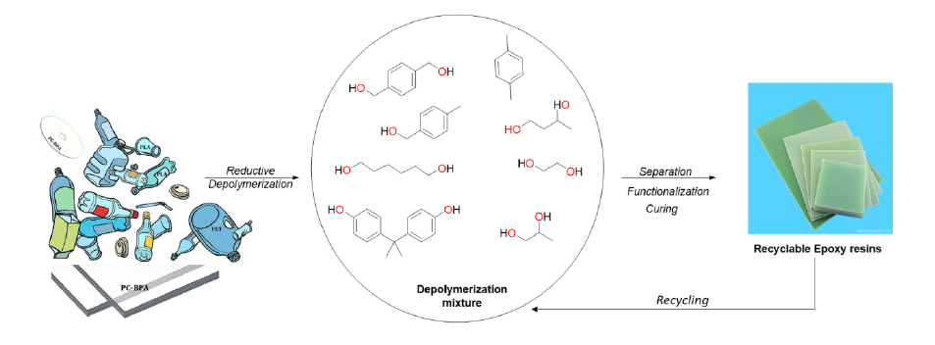

Valorisation potential - Application fields for the developed technology
- chemical recycling process for heteropolymer mixtures: technically scalable reductive depolymerization process for mixtures of oxygenated polymer materials recycling which is complementary to mechanical recycling and pyrolysis.
- scalable and energy efficient downstream processing (DSP) technique for the purification of plastic depolymerization streams.
- valorisation of depolymerized streams via synthesis of recyclable epoxy resins.
- recycling of the formulated epoxy resins by different methods (pyrolysis, solvolysis and reductive depolymerization).

Companies are invited to describe their support and commitment as well as their willingness and readiness to follow-up in R&D with the project results. Specific companies’ interests could be divided to the three following categories: feedstock supply, catalyst production, recycling process and epoxy resins formulation, consumption and recycling.

For substantive questions about this project proposal, please contact MOT2 representative Wannes Libbrecht (wlibbrecht@catalisti.be; +32 499 315 604).

Abstract CoRe²-2
Circular use of step-growth end-of-life polymers for monomer/oligomer recovery and reuse II

CoRe² aims at inventive chemical processes to revalorize waste fractions containing polyamides, polycarbonates and polyesters. Chemolytic routes providing controlled polymer splitting to chemical building blocks are highly preferred over physical recycling options, especially when most waste streams are impure or collected as polymer blends or inseparable layered materials,. The 18 M pre-phase of the project has already revealed strong leads for (i) selective dissociation of polyesters, polycarbonates and polyamides in polymer blends into their monomers, (ii) the catalytic conversion of splitting products (e.g. aliphatic amides from polyamides, e.g. bisphenols from polycarbonate) to high-value diamines, and (iii) the upcycling of end-of-life PET to high-performance thermoplastic co-polyesters (TPCs).

Based on these lead findings, CoRe² will strongly expand the fraction of polyesters, polycarbonates and polyamides that can be recycled to high-value monomers or polymers, and this at low temperatures (< 150oC) and reaction times (< 1 hr). A chief target is the selective upcycling of polyesters from mixed fiber waste, in particular textiles, as well as full chemical recycling options for physically inseparable polyester-polycarbonate-polyamide mixtures. A portfolio of catalytic methods will be designed to produce valuable linear aliphatic, cycloaliphatic or aromatic diamines. Re-using the obtained monomers, and integrating building blocks gained through chemcycling, we will design high-performance polymers like TPCs and polyphthalamides. New kinetic algorithms will be developed as tools for controlling and steering de/re-polymerisation in an industrial context, facilitating the take-up at higher TRL level.

The project results can be directly valorized by
- waste recycling companies: they can implement the innovative upcycling routes proposed for polyesters (other than bottle PET), polyamides, polycarbonates, etc, especially for physically inseparable mixtures;
- polyurethane producers, polyamide producers: they can use the diamines that are sourced from waste feedstocks rather than from virgin fossil feeds; also amine manufacturers can benefit;
- textile companies: we hand them concepts to produce / use fibers that are designed for recycling;
- (co)polyester/(co)polyamide manufacturers: they can produce thermoplastic copolyesters and polyphthalamides using a range of recycled monomers;
- polymer producing companies aiming at software for kinetic and process control.

For substantive questions about this project proposal, please contact MOT2 representative Wannes Libbrecht (wlibbrecht@catalisti.be; +32 499 315 604).

Abstract ReSet-2
Dynamic crosslinking chemistries for on-demand debondable adhesives

ReSet-2 is a continuation of the sprint project ReSet (Recyclable thermosets) in which the applicants will only focus on the implementation of dynamic crosslinking chemistries for on-demand debondable adhesives. After direct contact with all relevant adhesive companies in Flanders recently, it became clear that the importance of adhesive bonding technology is expected to grow quite significantly as a result of a multitude of industry trends, driven by environmental as well as economic reasons. For example, within the automotive industry the growth in adhesives usage is driven by the need to reduce weight, improving fuel economy and electrification of vehicles. On the other hand, within the construction industry, modular and prefab building techniques as well as improving the overall energy efficiency of buildings are key drivers. Changing EU policies such as the “European Green Deal” provides a strong push to transition from linear towards circular economy models and material streams. In the coming years, much progress will thus have to be made to substantially increase the durability, maintenance, repair, remanufacturing and recycling of goods. However, current adhesive solutions – around 50% reactive one/two-component (1K or 2K) systems – result in permanently crosslinked adhesives. While they are designed to provide long-term stability, they hamper material circularity. Thus, the development of new technologies and processes for easy recycling and reuse of bonded materials and thus keeping carbon in materials in circulation throughout the value chain, is of utmost industrial interest. It has therefore been recognized that on-demand debondable adhesives should become a key technology for facile and controlled/ triggered disassembly of adhesively bonded products (multimaterials) in the upcoming decade.

Starting from the knowledge build-up during the sprint SBO, ReSet-2 will focus on two thermally triggered reversible adhesive platforms. On the one hand, a novel tuneable dynamic chemistry platform is targeted towards the development of different types of debondable structural adhesives. On the other hand, a next generation of pressure sensitive adhesives (PSA) will be aimed for by the implementation of an acrylic-based dynamic chemistry platform. Besides the further application of cutting-edge in-silico engineering tools and in-depth characterization of the material properties (e.g. rheology, adhesive properties,…), a high throughput approach will be developed to broaden the screening of adhesive formulations and to speed up the design and industrial uptake of the new adhesive materials in sectors ranging from transportation to construction.

Schematic representation of temperature triggered on-demand debondable adhesives
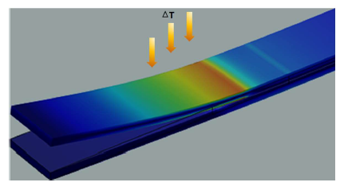

For substantive questions about this project proposal, please contact MOT2 representative Wannes Libbrecht (wlibbrecht@catalisti.be; +32 499 315 604).

